EXPERIMENT 9:
PROGRAM CODE:
# TELEMETRY DATA INGESTION AND VISUALIZATION
import numpy as np
import pandas as pd
import matplotlib.pyplot as plt
import json
import zipfile
import os
from IPython.display import display
from google.colab import files
np.random.seed(24)
OUTPUT_DIR = "/content/telemetry_project"
os.makedirs(OUTPUT_DIR, exist_ok=True)
print("=" * 80)
print("TELEMETRY DATA INGESTION AND TIME-SERIES VISUALIZATION")
print("=" * 80)
print("\n1. TELEMETRY DATA GENERATION")
number_of_readings = 500
timestamps = pd.date_range(
end=pd.Timestamp.now().floor("s"),
periods=number_of_readings,
freq="min"
)

temperature = 28 + 3 * np.sin(np.linspace(0, 8, number_of_readings)) \
+ np.random.normal(0, 0.8, number_of_readings)

humidity = 60 + 8 * np.sin(np.linspace(0, 6, number_of_readings) + 1) \
+ np.random.normal(0, 2, number_of_readings)
pressure = 1013 + 4 * np.sin(np.linspace(0, 5, number_of_readings)) \
+ np.random.normal(0, 1, number_of_readings)
device_status = np.random.choice(
["ONLINE", "ONLINE", "ONLINE", "OFFLINE"],
size=number_of_readings
)
df = pd.DataFrame({
"timestamp": timestamps,
"device_id": "SENSOR_001",
"temperature_C": np.round(temperature, 2),
"humidity_percent": np.round(humidity, 2),
"pressure_hPa": np.round(pressure, 2),
"device_status": device_status
})
print("Total telemetry records:", len(df))
print("Time range:", df["timestamp"].min(), "to", df["timestamp"].max())
print("\nSample telemetry records:")
display(df.head(10))
# 2. TIME-SERIES DATABASE-STYLE INGESTION
print("\n" + "=" * 80)
print("2. TIME-SERIES DATA INGESTION")
print("=" * 80)
# A timestamp-indexed DataFrame represents the stored time-series data.
time_series_db = df.set_index("timestamp").sort_index()
print("Records ingested:", len(time_series_db))
print("Timestamp index:", isinstance(time_series_db.index, pd.DatetimeIndex))
print("Missing values:\n", time_series_db.isnull().sum())
print("\nStored data preview:")
display(time_series_db.head())
# 3. TELEMETRY STATISTICS AND THRESHOLD ALERTS
print("\n" + "=" * 80)
print("3. TELEMETRY STATISTICS AND ALERT DETECTION")
print("=" * 80)
sensor_columns = [
"temperature_C",
"humidity_percent",
"pressure_hPa"
]
summary = df[sensor_columns].agg(
["mean", "min", "max", "std"]
).T.reset_index()
summary.columns = [
"Sensor", "Average", "Minimum", "Maximum", "Standard Deviation"
]
display(summary.round(2))
# Example threshold rules; adjust them for your application.
df["temperature_alert"] = df["temperature_C"] > 32
df["humidity_alert"] = df["humidity_percent"] > 75
df["pressure_alert"] = df["pressure_hPa"] > 1018
df["alert_status"] = np.where(
df[["temperature_alert", "humidity_alert", "pressure_alert"]]
.any(axis=1),
"ALERT",
"NORMAL"
)
print("\nAlert counts:")
print(df["alert_status"].value_counts())
print("\nRecords that triggered alerts:")
alert_records = df[df["alert_status"] == "ALERT"]
display(alert_records.head(10))
# 4. TIME-SERIES VISUALIZATION
print("\n" + "=" * 80)
print("4. HISTORICAL TIME-SERIES PLOTS")
print("=" * 80)
plot_metrics = [
("temperature_C", "Temperature Over Time", "Temperature (°C)"),
("humidity_percent", "Humidity Over Time", "Humidity (%)"),
("pressure_hPa", "Pressure Over Time", "Pressure (hPa)")
]
for column, title, ylabel in plot_metrics:
plt.figure(figsize=(12, 4))
plt.plot(df["timestamp"], df[column], linewidth=1.2)
plt.title(title)
plt.xlabel("Timestamp")
plt.ylabel(ylabel)
plt.grid(True, alpha=0.3)
plt.xticks(rotation=30)
plt.tight_layout()
plt.show()
# 5. SENSOR COMPARISON DASHBOARD
print("\n" + "=" * 80)
print("5. SENSOR COMPARISON DASHBOARD")
print("=" * 80)
fig, axes = plt.subplots(1, 3, figsize=(15, 4))
for ax, (column, title, ylabel) in zip(axes, plot_metrics):
ax.hist(df[column], bins=25, edgecolor="black")
ax.set_title(title)
ax.set_xlabel(ylabel)
ax.set_ylabel("Frequency")
ax.grid(axis="y", alpha=0.3)
plt.suptitle("Telemetry Distribution Comparison")
plt.tight_layout()
plt.show()
# Normalized trend comparison lets us compare differently scaled sensors.
normalized_df = df[sensor_columns].copy()
for column in sensor_columns:
minimum = normalized_df[column].min()
maximum = normalized_df[column].max()
if maximum > minimum:
normalized_df[column] = (
normalized_df[column] - minimum
) / (maximum - minimum)
else:
normalized_df[column] = 0.0
plt.figure(figsize=(12, 5))
for column in sensor_columns:
plt.plot(
df["timestamp"],
normalized_df[column],
label=column
)
plt.title("Normalized Telemetry Comparison")
plt.xlabel("Timestamp")
plt.ylabel("Normalized value (0 to 1)")
plt.legend()
plt.grid(True, alpha=0.3)
plt.xticks(rotation=30)
plt.tight_layout()
plt.show()
# 6. DASHBOARD KPI SUMMARY
print("\n" + "=" * 80)
print("6. DASHBOARD KEY PERFORMANCE INDICATORS")
print("=" * 80)
online_percentage = (
df["device_status"].eq("ONLINE").mean() * 100
)
kpis = pd.DataFrame({
"KPI": [
"Total readings",
"Average temperature (°C)",
"Average humidity (%)",
"Average pressure (hPa)",
"Online readings (%)",
"Alert records"
],
"Value": [
len(df),
round(df["temperature_C"].mean(), 2),
round(df["humidity_percent"].mean(), 2),
round(df["pressure_hPa"].mean(), 2),
round(online_percentage, 2),
int(df["alert_status"].eq("ALERT").sum())
]
})
display(kpis)
# 7. EXPORT FOR POWER BI, TABLEAU AND GRAFANA INTEGRATION
print("\n" + "=" * 80)
print("7. EXPORTING FILES FOR DASHBOARD INTEGRATION")
print("=" * 80)
# CSV for Power BI, Tableau and other data tools.
csv_path = os.path.join(OUTPUT_DIR, "telemetry_data.csv")
df.to_csv(csv_path, index=False)
# Summary CSV for KPI cards and aggregate dashboard visuals.
summary_path = os.path.join(OUTPUT_DIR, "telemetry_summary.csv")
kpis.to_csv(summary_path, index=False)
# JSON records suitable for further processing or API ingestion.
json_path = os.path.join(OUTPUT_DIR, "telemetry_data.json")
df_json = df.copy()
df_json["timestamp"] = df_json["timestamp"].astype(str)
with open(json_path, "w") as f:
json.dump(df_json.to_dict(orient="records"), f, indent=2)
# Grafana data-source configuration example.
# This file is illustrative; it does not create a Grafana data source.
grafana_info = {
"project": "Telemetry Time-Series Visualization",
"data_source_required": True,
"suggested_data_sources": [
"InfluxDB",
"PostgreSQL",
"Prometheus (with a suitable ingestion pipeline)"
],
"csv_file": "telemetry_data.csv",
"timestamp_column": "timestamp",
"metrics": sensor_columns,
"note": "Configure Grafana with a supported data source and ingest the data."
}
grafana_path = os.path.join(OUTPUT_DIR, "grafana_integration_info.json")
with open(grafana_path, "w") as f:
json.dump(grafana_info, f, indent=2)
# Package every exported file into one ZIP.
zip_path = "/content/telemetry_dashboard_exports.zip"
with zipfile.ZipFile(zip_path, "w", zipfile.ZIP_DEFLATED) as z:
for filename in os.listdir(OUTPUT_DIR):
z.write(
os.path.join(OUTPUT_DIR, filename),
arcname=filename
)
print("Exported files:")
for filename in sorted(os.listdir(OUTPUT_DIR)):
print(" -", filename)
print("\nZIP package:", zip_path)
# 8. FINAL RESULT
print("\n" + "=" * 80)
print("PROJECT EXECUTION SUMMARY")
print("=" * 80)
print("1. Simulated telemetry generated successfully.")
print("2. Timestamp-indexed time-series dataset created.")
print("3. Sensor statistics and threshold alerts calculated.")
print("4. Historical time-series and comparative plots generated.")
print("5. Dashboard KPI summary generated.")
print("6. CSV and JSON integration files exported.")
print("\nNOTE:")
print("These are simulated readings, not live physical sensor data.")
print("Grafana, Power BI and Tableau dashboards must be configured")
print("inside their respective applications to become working dashboards.")
# Download the complete export package.
files.download(zip_path)
OUTPUT:
================================================================================
TELEMETRY DATA INGESTION AND TIME-SERIES VISUALIZATION
================================================================================

1. TELEMETRY DATA GENERATION
Total telemetry records: 500
Time range: 2026-10-19 23:16:33 to 2026-10-20 07:35:33

Sample telemetry records:
 | timestamp | device_id | temperature_C | humidity_percent | pressure_hPa | device_status
0 | 2026-10-19 23:16:33 | SENSOR_001 | 29.06 | 66.18 | 1013.19 | ONLINE
1 | 2026-10-19 23:17:33 | SENSOR_001 | 27.43 | 67.13 | 1012.23 | ONLINE
2 | 2026-10-19 23:18:33 | SENSOR_001 | 27.84 | 66.85 | 1014.80 | ONLINE
3 | 2026-10-19 23:19:33 | SENSOR_001 | 27.35 | 68.35 | 1012.96 | ONLINE
4 | 2026-10-19 23:20:33 | SENSOR_001 | 27.34 | 70.89 | 1012.60 | ONLINE
5 | 2026-10-19 23:21:33 | SENSOR_001 | 27.09 | 67.65 | 1013.62 | ONLINE
6 | 2026-10-19 23:22:33 | SENSOR_001 | 28.74 | 66.93 | 1012.11 | ONLINE
7 | 2026-10-19 23:23:33 | SENSOR_001 | 28.57 | 70.46 | 1013.66 | ONLINE
8 | 2026-10-19 23:24:33 | SENSOR_001 | 27.08 | 69.72 | 1010.95 | OFFLINE
9 | 2026-10-19 23:25:33 | SENSOR_001 | 28.61 | 66.27 | 1012.80 | OFFLINE

================================================================================
2. TIME-SERIES DATA INGESTION
================================================================================
Records ingested: 500
Timestamp index: True
Missing values:
device_id 0
temperature_C 0
humidity_percent 0
pressure_hPa 0
device_status 0
dtype: int64

Stored data preview:
 | device_id | temperature_C | humidity_percent | pressure_hPa | device_status
timestamp
2026-10-19 23:16:33 | SENSOR_001 | 29.06 | 66.18 | 1013.19 | ONLINE
2026-10-19 23:17:33 | SENSOR_001 | 27.43 | 67.13 | 1012.23 | ONLINE
2026-10-19 23:18:33 | SENSOR_001 | 27.84 | 66.85 | 1014.80 | ONLINE
2026-10-19 23:19:33 | SENSOR_001 | 27.35 | 68.35 | 1012.96 | ONLINE
2026-10-19 23:20:33 | SENSOR_001 | 27.34 | 70.89 | 1012.60 | ONLINE

3. TELEMETRY STATISTICS AND ALERT DETECTION
 | Sensor | Average | Minimum | Maximum | Standard Deviation
0 | temperature_C | 28.40 | 22.80 | 32.93 | 2.27
1 | humidity_percent | 59.87 | 47.55 | 73.11 | 6.04
2 | pressure_hPa | 1013.51 | 1006.93 | 1019.21 | 3.03

Alert counts:
alert_status
NORMAL 479
ALERT 21
Name: count, dtype: int64

Records that triggered alerts:
 | timestamp | device_id | temperature_C | humidity_percent | pressure_hPa | device_status | temperature_alert | humidity_alert | pressure_alert | alert_status
71 | 2026-10-20 00:27:33 | SENSOR_001 | 32.50 | 68.48 | 1017.52 | OFFLINE | True | False | False | ALERT
73 | 2026-10-20 00:29:33 | SENSOR_001 | 30.50 | 65.35 | 1018.15 | ONLINE | False | False | True | ALERT
75 | 2026-10-20 00:31:33 | SENSOR_001 | 32.05 | 68.21 | 1016.48 | ONLINE | True | False | False | ALERT
79 | 2026-10-20 00:35:33 | SENSOR_001 | 32.45 | 70.02 | 1017.36 | ONLINE | True | False | False | ALERT
85 | 2026-10-20 00:41:33 | SENSOR_001 | 32.02 | 66.05 | 1016.74 | ONLINE | True | False | False | ALERT
94 | 2026-10-20 00:50:33 | SENSOR_001 | 32.57 | 65.77 | 1014.35 | ONLINE | True | False | False | ALERT
112 | 2026-10-20 01:08:33 | SENSOR_001 | 32.04 | 63.49 | 1016.46 | ONLINE | True | False | False | ALERT
115 | 2026-10-20 01:11:33 | SENSOR_001 | 32.57 | 67.39 | 1016.80 | OFFLINE | True | False | False | ALERT
122 | 2026-10-20 01:18:33 | SENSOR_001 | 30.84 | 67.45 | 1019.21 | ONLINE | False | False | True | ALERT
138 | 2026-10-20 01:34:33 | SENSOR_001 | 28.95 | 66.62 | 1018.82 | ONLINE | False | False | True | ALERT

================================================================================
4. HISTORICAL TIME-SERIES PLOTS
================================================================================
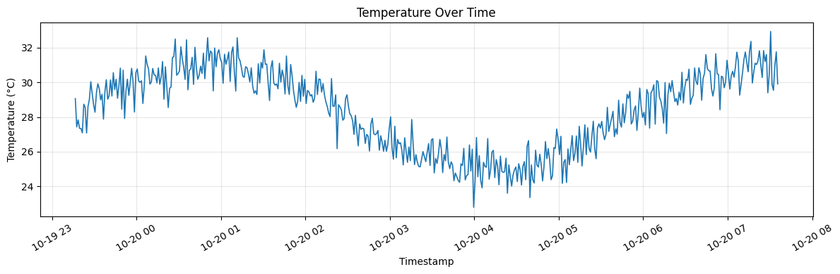
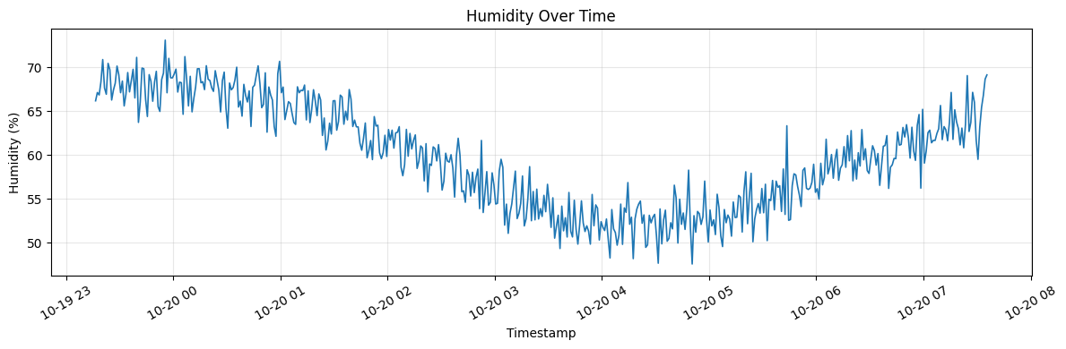
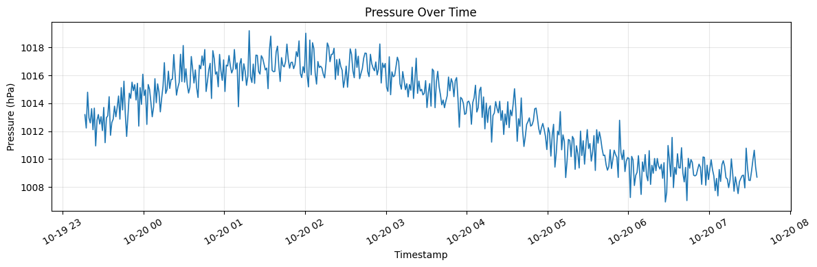

================================================================================
5. SENSOR COMPARISON DASHBOARD
================================================================================


